# Section: 15-2: Sixth to Eighth Vassa- Age 40 - 42 Years

This section describes how the Buddha spent his sixth, seventh, and eighth rainy seasons. As the scriptures do not provide many details about the locations where the Blessed One resided during these rainy seasons, we must rely on other sources to fill in the gaps.

Sixth Vassa (Age 40)

According to Tradition and various sources, the Blessed One spent his sixth rainy season at Maṅkula Hills:

1)The sixth on Maṅkula hills (*chaṭṭhaṁ Maṅkulapabbate****).*** [1]

2) The Buddha, the repository of endless virtues, having charming eyes like blossoming, very blue, spotless water-lilies, radiating with his radiant gold-like body, in the sixth Rains Retreat, dwelt on the great Mount Maṅkula . [2]

(*phullātinīlavimaluppalacārunetto- siṅgīsamānatanujotihi jotamāno  
buddho anantaguṇasannidhi chaṭṭhavasse- vāsaṁ akā vipulamaṅkulapabbatasmiṁ).*

3) *“The Buddha kept the sixth vassa at Mount Maṅkula Monastery, which was situated by the side of the ocean and was shaded and walled by a forest of star flower trees.”* [3]

4) “The Buddha spent his sixth rainy season at a monastery in the Chaya Forest, near Maṅkula hills. The exact location of the Chaya Forest is unknown.” [4]

## Where are the Maṅkula hills?

The Maṅkula Hills of ancient India, during the time of the Buddha, are not marked on modern Indian maps. Some researchers suggest that the ancient Maṅkula Hills are now known as the Prabhosa Hills and caves region, located in the present-day Kosambi district. [5]

The following extracts provide some insight into the possible location of the Maṅkula Hills (*Maṅkula Pabba*).

*1) “ We read that Ānanda and a group of monks went from Kosambī to inspect the Pilakkha Tree Cave and while there they met a large group of wandering ascetics. This must refer to one of the caves or rock overhangs on Prabhosa Hill some eight kilometres west of Kosambī. Pabhosa may be the Maṅkula Hill where the commentaries say the Buddha spent his sixth rainy season. Archaeological evidence shows that this hill was the abode of ascetics for centuries” [6]*

*2) “…  Prabhosa, this hill was known in ancient times as Mankula and is where the Buddha spent his sixth rains retreat. There are no discourses in the Tipitaka taught at Prabhosa so perhaps the Buddha spent the whole stay here in silence. If so, this would be quite understandable; Prabhosa is a particularly lonely and peaceful place. The Chinese pilgrim Hiuen Tsiang came here in the 7th century and saw a stupa built by King Asoka but neither this or any other Buddhist antiquities can be found here today. There are caves and rock shelters all over Prabhosa particularly on the steeper and rockier north side. The largest cave, now called Sita’s Window, may have been where the Buddha stayed during his visit. In later centuries it was the Jains who came to dominate PrabhoMapsa as is clear from their many inscriptions and images in the area. Climb to the top of the hill and you will get a sweeping view over the Yamuna River and the small temple town of Prabhosa nearby. About a kilometre from Kosambi the main road back to Allahabad branches to the left. Proceed along it for about 10 kilometres and you will come to Prabhosa” [7]*

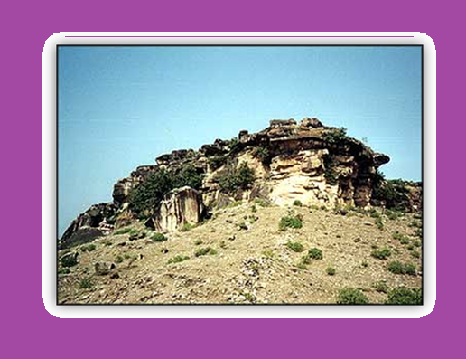

**Present day picture of Prabhosa hills ( Mankula Hills) [8]**

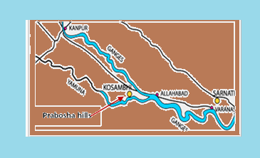

**Map showing the present-day location of Prabhosa hills (ancient Mankula Hiils) in Kosambi District of UP, India [9]**

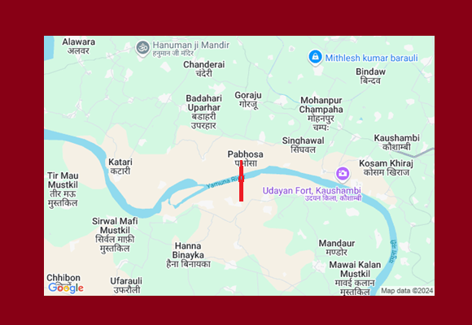

**Google Map showing the location of Pabbhosa in Kaushambi region [10]**

## Teachings Given at Mount Maṅkula

While the Blessed One delivered many discourses during his time in Kosambi, the scriptures do not mention any significant Dhamma teachings specifically during the sixth rainy season, when he stayed at Maṅkula Hills in Kosambi. However, historical Buddhist accounts suggest that two key events took place during this period:

1) Venerable Puṇṇa, after receiving permission from the Buddha, traveled to the country of Sunāparanta.

2) Queen Khema, the chief queen of King Bimbisara, became a disciple of the Buddha.

* **According to MN:145** (Puṇṇovāda Sutta), which was delivered to Venerable Puṇṇa while the Buddha was staying at the Jetavana Monastery, the Blessed One may have traveled to Sāvatthi before the rainy season to offer advice to Venerable Puṇṇa.
* **According to tradition**, Queen Khema attained stream-entry while listening to the Buddha’s sermon on the impurity of the body. Following this, the Buddha gave her a lengthy sermon, and she attained arahantship on the spot, still dressed in her royal attire. Later, she received permission from the king and became a disciple of the Buddha in Rājagaha. [11] Although the scriptures do not record her ordination, she was one of the chief bhikkhuni disciples of the Blessed One, and the Buddha declared her the foremost among bhikkhunis with great wisdom. [12]

End of the Sixth Rainy Season  
Tradition holds that after spending the sixth vassa at Mount Maṅkula, the Buddha traveled to Rājagaha and took up residence at the Veluvana Monastery. [13]

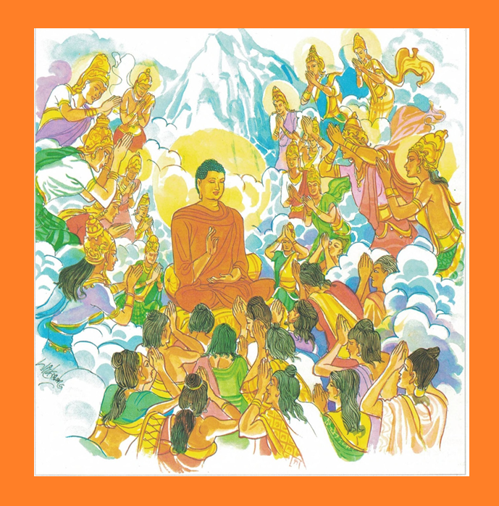

**The Buddha in Tāvatiṃsa deva world Teaching Dhamma to Devas there** **[14]**

Seventh Vassa (Age 41)  
According to various sources, the Buddha spent his seventh rainy season in the Tāvatimsa deva world:

**1)** The seventh in the realm of the thirty-three gods—Tāvatiṁsa. *(sattamaṁ Tāvatiṁsabhavane***). [15]**

**2)** Preaching the most profound, hard-to-see, sweet Dhamma to the *Maruts*, in the seventh Rains Retreat, the incomparable, glorious Sage, dwelt on the cool, large, stone throne of the Lord of Gods—Sakka (*Gambhīra-duddasa-taraṁ madhuraṁ Dhammaṁ Marūnaṁ desetvā, atulo siri-sannivāso Muni Deva-Inda-sītala-visāla-silā-āsanasmiṁ, sattamamhi Vassamhi, vāsaṁ akarī*). [16]

**3)** “The seventh vassa was observed on the Emerald Throne at the foot of Erythrina Indica tree in the celestial realm of [Tāvatiṃsa](https://www.wisdomlib.org/definition/tavatimsa" \l "theravada" \o "show Tāvatiṃsa definitions), preaching [Abhidhamma](https://www.wisdomlib.org/definition/abhidhamma#theravada) discourses.” [17]

## The Buddha’s Divine Teaching in Tāvatiṃsa Devaloka

Tradition holds that when the Buddha ascended to Tāvatiṃsa Devaloka, a great assembly of celestial beings gathered to listen to his teachings. Among them was his late mother, Queen Māyā, who had passed away seven days after his birth and was reborn as a youthful deva named Santusita Deva in the Tusita heaven (see Section 2).

Throughout the three-month vassa (rain retreat), the Buddha expounded the profound Abhidhamma to the devas and brahmas, illuminating the path to wisdom and liberation. Deeply moved by the sublime Dhamma, Santusita Deva attained the fruition of sotāpatti, the first stage of awakening, realizing the timeless truth her son had come to reveal to the world.[18]

According to tradition, during this period, the Buddha would descend to the human realm to share these precious teachings with his foremost disciple, Venerable Sāriputta. Then, as promised, on the full moon night of the Assayuja month, the Buddha returned to the human world in radiant splendour. His body shone with six-coloured rays, illuminating the heavens and the earth. Accompanied by a vast retinue of devas on one side and brahmas on the other, he descended to Saṅkassanagara, where an immense gathering, led by Venerable Sāriputta, awaited his arrival. The entire town glowed with divine brilliance, reflecting the reverence and devotion of all present.

Awestruck by the magnificent scene, Venerable Sāriputta respectfully approached the Blessed One and exclaimed,

***“Venerable, never have we seen or heard of such resplendent glory! Indeed, you are loved, homered, and revered by devas, brahmas, and humans alike!”***

In response, the Buddha revealed this profound truth:

**“Those noble and wise ones are intent on meditation.  
They are devoted to renunciation and inner peace.  
Mindful and enlightened, such beings are beloved by all.”** (Dhp:181)

*( ye dhirā jhānapasutā nekkhammūpasame ratā satīmataṃ  
tesaṃ sambuddhānaṃ devā api pihayanti)*

As the Buddha’s luminous words resounded, transformation unfolded, the monks who were disciples of Venerable Sāriputta attained arahantship, their minds utterly liberated. A great number of devotees in the congregation also reached sotāpatti fruition, forever stepping onto the path of awakening.

Thus, the Buddha’s compassionate journey to the celestial realm bore immeasurable fruit, bringing both gods and humans closer to the ultimate truth of Nibbāna.

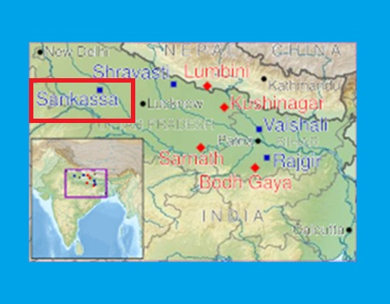

**Map of Sankissa in relation to other *Eight Great Places***[**Buddhist pilgrimage**](https://en.wikipedia.org/wiki/Buddhist_pilgrimage), **Saṅkassanagara is identified as Sankisa Basantpur, in UP, India [19]**

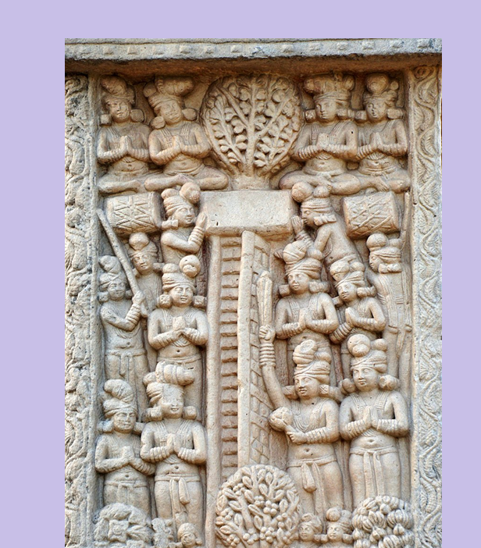

**Descent of the Buddha from the Tavatimsa Heaven  [20]**

**Note:**

Sankissa has ruins of ancient Buddhist monasteries, and other monuments from Buddhist and Hindu traditions. The Briton Alexander Cunningham explored the site in 1842. Around 300 years after the Gautama Buddha's [Mahaparinirvana](https://en.wikipedia.org/wiki/Mahaparinirvana" \o "Mahaparinirvana), king [Ashoka](https://en.wikipedia.org/wiki/Ashoka) visited and built a [Pillar of Ashoka](https://en.wikipedia.org/wiki/Pillars_of_Ashoka) of which the elephant capital survives. He also built a [stupa](https://en.wikipedia.org/wiki/Stupa) and a temple commemorating the Buddha's descent from the heavens. The ruins of the stupa are still present, as is a temple of Vishari Devi and an ancient staircase.

The location of the city gate of Sankissa is said to be at one of the "unchangeable" spots of the world, or *avijahitatthanam*, where all of the Buddhas descend to the human world after preaching the [dhamma](https://en.wikipedia.org/wiki/Abhidhamma) in the Heavens. From Sankissa, the Buddha went to [Jetavana](https://en.wikipedia.org/wiki/Jetavana" \o "Jetavana) grove. [21]

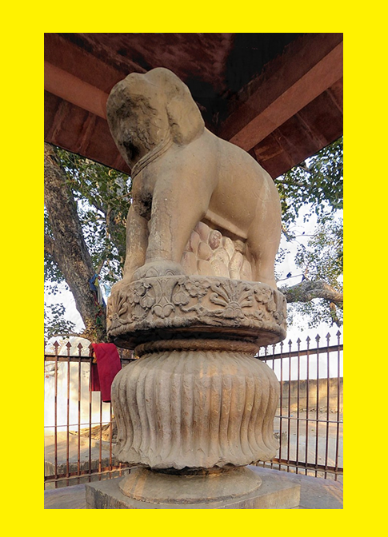

**Elephant capital at Sankasya [22]**

# Eighth Vassa (Age 42)

The eighth rainy season was spent in the Deer Park at Bhesakaḷā Grove on Suṃsumāragiri (Crocodile Hill) in Bhagga Country. According to the scriptures, before the eighth rainy season, the Buddha had visited Bhesakaḷā Grove while residing at the Veluvana Monastery in Rājagaha. In Section 14-1, an event is described in which Venerable Moggallāna became an arahant, and on that occasion, the Blessed One was dwelling among the Bhaggas at Suṃsumāragiri, in the Deer Park at Bhesakaḷā Grove. [23]

The Bodhirajakumara Sutta (MN:85) also mentions an earlier occasion when the Blessed One was living in Suṃsumāragiri. Prince Bodhi said the following: [24]

*“…there was also an occasion when the Blessed One was living here in the country of the Bhaggas at Suṁsumāragira in the Bhesakaḷā Grove, the Deer Park. Then my nurse, carrying me on her hip, went to the Blessed One, and after paying homage to him, she stood at one side and said to him: ‘Venerable sir, this Prince Bodhi goes to the Blessed One for refuge and to the Dhamma and to the Sangha of bhikkhus. Let the Blessed One remember him as a lay follower who has gone to him for refuge for life…”*

On the first occasion, Prince Bodhi was a child, but on the second occasion, the Buddha visited his palace at the prince’s invitation and delivered the discourse mentioned above.

The following extracts from other sources indicate that the Blessed One spent his eighth rainy season in Bhagga country:

1) *“He, the Excellent Victor over Māra… in his eighth Rains Retreat, dwelt in the pleasing Bhesakalā Wood on the mountain named Crocodile Hill”* [25]

2) “*The eighth in the Bhesakaḷā Wood, relying on the Crocodile Hill amongst the Bhaggas*” [26].

3) The eighth *vassa* was spent in the forest of pigeon peas, a wildlife sanctuary, (or the forest governed by a celestial ogress) with Susumaragiri in the [Bhagga](https://www.wisdomlib.org/definition/bhagga" \l "theravada" \o "show Bhagga definitions) country as His alms-food resort . [27]

## Where was Bhagga country?

During the time of the Buddha, Bhagga country was part of Avanti, one of the sixteen major states of ancient India. The Bhaggas lived between the Gangā and Yamunā rivers, to the north of the Vatsa kingdom's capital, Kosāmbī, and to the west of the Kāsī kingdom's capital, Vārāṇasī (see Section 13 for details of the sixteen major states).

To the north of Bhagga country lay the kingdom of Kosala. The capital of the Bhaggas was Suṃsumāragiri, where Bhesakaḷā Grove, the Deer Park, was situated. Suṃsumāragiri is identified with modern-day Chunar, located about twenty kilometres upstream from Varanasi along the Ganges, and is known for the impressive fortress that now stands atop the hill. [28]

According to the scriptures, there were several occasions when the Buddha and his disciples resided in Bhesakaḷā Grove. **See**: MN:15: Anumāna Sutta, MN:50: Māratajjanīya Sutta, MN: 85: Bodhirājakumāra Sutta.

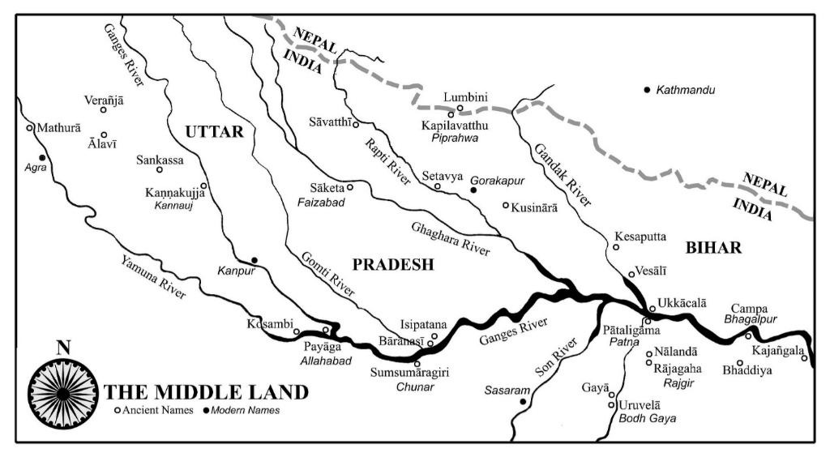

**Location of** [**Suṃsumāragiri**](https://en.wikipedia.org/w/index.php?title=Su%E1%B9%83sum%C4%81ragiri&action=edit&redlink=1) **(Chunar) in UP, India [29]**

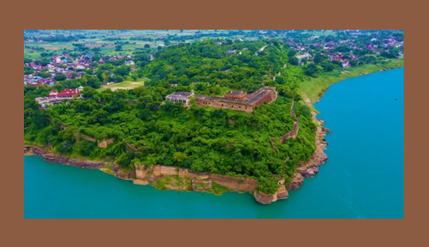

**Modern day picture of Chunar Fort [30]**

Chunar, an ancient town on the banks of the sacred river Ganga, is a cultural heritage of India, located around 40 km from Varanasi, this town in Mirzapur district is adorned with historical treasures, including the Chunar Fort—an architectural masterpiece commissioned by Maharaja Vikramaditya, king of Ujjain. [31]

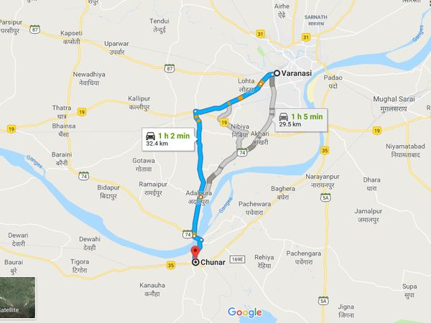

**Present day map showing the location of Chunar along the bank of Ganges River [32]**

## Significant Events During This Period

The Meeting of Nakulapitā and Nakulamātā with the Buddha**.** **[33]**

According to tradition, Nakulapitā, a wealthy man from Bhagga country, and his wife, Nakulamātā, visited the Buddha while he was spending the rainy season in the Bhesakaḷā forest. Upon seeing the Buddha for the first time, the couple immediately recognized him as their own son from a past life and said:

*“…beloved son…where have you been roaming about for such a long time after leaving us, your parents behind?”[34]*

According to the commentary, Nakulapitā and his wife, Nakulamātā, had been the Buddha’s parents in five hundred past lives, which is why they continued to regard him as their son. [35]

## Teachings Given to Nakulapitā and Nakulamātā

### Advice for Couples Wishing for Happiness in This Life and Beyond

One day, Nakulapitā and Nakulamātā approached the Buddha and expressed their deep devotion to each other. They shared that they had lived together in harmony in their present life and wished to continue as husband and wife in future lives as well.

In response, the Buddha offered them this profound teaching:

*“Both husband and wife are endowed with faith,*

*charitable and self-controlled,*

*living their lives righteously,*

*addressing each other with pleasant words,*

*Then many benefits accrue to them*

*and they dwell at ease.*

*Their enemies are saddened*

*when both are the same in virtue.*

*Having practiced the Dhamma here,*

*the same in virtuous behaviour and observances,*

*delighting after death in a deva world,*

*they rejoice, enjoying sensual pleasures. [36]*

### Nakulapitā’s Illness and Nakulamātā’s Reassurance

On one occasion, Nakulapitā fell gravely ill and became deeply worried about the future of his family. He was concerned about whether Nakulamātā would be able to support their children and manage the household on her own. Sensing his distress, Nakulamātā gently reassured him. She spoke of her strength, virtue, and unwavering faith as a lay follower of the Buddha. She assured him of her ability to care for the household, urging him to set aside his worries and find peace:

*“Do not die full of concern, householder. To die full of concern is painful. To die full of concern has been criticized by the Blessed One. ”[37]*

Hearing her words, Nakulapitā was filled with joy and relief, and remarkably, his illness began to subside. Later, he approached the Buddha and recounted this experience. In response, the Blessed One said:

“*It is truly your good fortune and gain, householder, that the housewife Nakulamātā has compassion for you, desires your good, and exhorts and instructs you. She is one of my white-robed females lay disciples who fulfill virtuous behaviour… who obtain internal serenity of mind… who have attained a foothold, a firm stand, assurance in this Dhamma and discipline… crossed over doubt… and become independent of others in the Teacher’s teaching (*established in stream entry*).* ” [38]

### Keeping the Mind Calm When the Body Is Sick

On one occasion, Nakulapitā approached the Buddha and sought his guidance, saying that as he had grown older, his body frequently fell ill. He asked the Blessed One for advice on how to maintain inner peace despite his physical ailments. In response, the Buddha said: [39]

*“ So it is, householder, so it is! This body of yours is afflicted, weighed down, encumbered. If* anyone carrying around this body were to claim to be healthy even for a moment, what is that *due to other than foolishness? Therefore, householder, you should train yourself thus: ‘Even though I am afflicted in body, my mind will be unafflicted’”.*

### Advice for a Good Rebirth

While the Buddha was residing in the Deer Park at Bhesakalā, he delivered a discourse to Nakulamātā, describing eight qualities of a virtuous wife that would lead to a favourable rebirth in the deva realm. [40]

### Nakulapitā’s Six Noble Qualities

On another occasion, the Buddha declared that Nakulapitā, by possessing six noble qualities—unwavering confidence in the Buddha, Dhamma, and Saṅgha, noble virtuous conduct, profound knowledge, and noble liberation—had attained certainty about the Tathāgata and become a seer of the deathless, one who lived having realized the deathless. [41]

Thus, Nakulapitā and Nakulamātā not only devotedly supported the Buddha and the Saṅgha but also deeply understood the Dhamma with great reverence. As a result, they both attained the stage of stream-entry—the first step on the Noble Path—laying the foundation for ultimate enlightenment and liberation from the cycle of suffering in saṃsāra.

### Teachings Given to Venerable Anuruddha

The *Anuruddha Sutta* (AN 8:30) records that while the Buddha was residing among the Bhaggas at Suṃsumāragiri in the Deer Park at Bhesakalā Grove, he visited Venerable Anuruddha, who was then staying at the Eastern Bamboo Park in the Cetiya country. During this visit, the Buddha delivered a discourse, the key teachings of which are summarized in section 14.2 of this compilation.

### Teachings Given to Prince Bodhi

On another occasion, while residing at the Kokanada Palace in the Bhagga country, the Buddha was visited by Prince Bodhi, who approached him with a question:

*“Venerable sir, when a bhikkhu finds the Tathāgata to discipline him, how long is it until by realising for himself with direct knowledge?”[42]*

The Blessed One imparted the following teaching to Prince Bodhi:

A follower of the Buddha who seeks to train under him must possess five essential qualities:

1. **Confidence in the Buddha** – unwavering faith in his enlightenment and teachings.
2. **Good health** – being free from illness and affliction to undertake the practice effectively.
3. **Honesty and sincerity** – maintaining truthfulness in thought, speech, and action.
4. **Diligence in practice** – being energetic in abandoning unwholesome states and cultivating wholesome qualities.
5. **Wisdom** – possessing insight into the arising and passing away of phenomena, a noble and penetrating wisdom that leads to the complete cessation of suffering.

When a bhikkhu possesses these five qualities and trains under the guidance of the Buddha, he may attain liberation within seven years, six years, or even within a single month, depending on the development of his faculties. In some cases, he may realize the truth in just half a month, seven days and nights, or even within a single day and night.

Furthermore, if a bhikkhu endowed with these five factors of striving finds a Tathāgata to guide him, he may attain realization in a single session of instruction—receiving guidance in the evening and reaching distinction by morning, or receiving instruction in the morning and attaining insight by evening.

Deeply inspired by the Buddha’s words, Prince Bodhi rejoiced in the teaching and became a devoted lay follower. [43]

With this inspiring teaching of the Blessed One , we conclude this section, which explored the Blessed One’s rainy season retreats during his sixth to eighth vassa, spent in three different locations. In the next section (15-3), we will examine where the Buddha spent his ninth vassa.

### End Notes: Section-15-2

1. Source 1: Madhuratthavilāsinī (Buddhavaṁsatthakathā) of Bhadantâcariya Buddhadatta Mahathera: Translated by I. B. Honer, 1946.
2. Source 2: Jinacaritaṁ, The Life of the Victorious Buddha, translated by Bhikkhu Anandajoti.
3. Source 3: Chapter 24: The Great Chronicles of the Buddhas by Venerable Mingun Sayadaw.
4. Source 4: Where did Lord Gautama Buddha spend the 45 rains retreats? by Dr. Ari Ubeysekara: <https://drarisworld.wordpress.com/>
5. Mankulapabbata**:** a locality where the Buddha spent his sixth Rainy Retreat *(vassa)*(BuA.3). Source: Dictionary of Pāli Proper Names by G.P. Malalasekera.
6. Source: Footprints in the Dust:The Life of the Buddha from the Most Ancient Sources by Bhante S. Dhammika.
7. Prabhosa: The hill where the Buddha spent his sixth rains retreat:Source: <https://www.buddhanet.net/>.
8. Source: <https://www.buddhanet.net/>
9. Ibid.
10. Pabhosa is a Village in Sarsawan Block in Kaushambi District of Uttar Pradesh State, India. It belongs to Allahabad Division . It is located 26 KM towards South from District head quarters Manjhanpur. 9 KM from Sarasawan, 199 KM from State capital Lucknow, Source:

    <https://www.onefivenine.com/india/villages/Kaushambi/Sarsawan/Pabhosa>
11. See: Great Disciples of the Buddha by Bhikkhu Nyanaponika & Hellmuth Hecker.
12. AN1:236.
13. Chapter 24: The Great Chronicles of the Buddhas by Venerable Mingun Sayadaw.
14. Source: Wisdom Library: <https://www.wisdomlib.org/buddhism/book/dhammapada-illustrated/d/doc1084402.html>
15. Source 1: Madhuratthavilāsinī (Buddhavaṁsatthakathā) of Bhadantâcariya Buddhadatta Mahathera: Translated by I. B. Honer, 1946.
16. Source 2: Jinacaritaṁ, The Life of the Victorious Buddha, translated by Bhikkhu Anandajoti.
17. Chapter 25: The Great Chronicles of the Buddhas by Venerable Mingun Sayadaw.
18. Source: Wisdom Library: <https://www.wisdomlib.org/buddhism/book/dhammapada-illustrated/d/doc1084402.html>
19. Source: Wikipedia:
20. Photograph by Anandajoti Bhikkhu [CC BY 2.0](https://creativecommons.org/licenses/by/2.0): <https://en.wikipedia.org/wiki/Sankissa#/media/File:Descent_of_the_Buddha_from_the_Trayastrimsa_Heaven_Sanchi_Stupa_1_Northern_Gateway.jpg>
21. <https://en.wikipedia.org/wiki/Sankissa>
22. Author: [**J. Homany**](https://www.flickr.com/photos/riesenj/) : <https://en.wikipedia.org/wiki/Sankissa#/media/File:Elephant_capital_Sankasya.jpg>
23. AN:7:61. See: section 14-1. It is mentioned there how the Buddha guided Venerable Moggallāna to achieved arhantship.
24. Prince Bodhi was the son of King Udena of Kosambı̄; his mother was the daughter of King

    Ca˚nḍappajjota of Avantı̄. He was childless and desired a son. He had heard that people can fulfil their wishes by making special offerings to the Buddha, so he spread the white cloth with the idea: “If I am to have a son, the Buddha will step on the cloth; if I am not to have a son, he will not step on the cloth.” The Buddha knew that by reason of past evil kamma, he and his wife were destined to remain childless. Hence, he did not step on the cloth. Later, he laid down a disciplinary rule prohibiting the bhikkhus from stepping on a white cloth, but subsequently modified the rule to allow bhikkhus to step on a cloth as a blessing for householders. See: MN: Notes: 816 & 817, p.1139.
25. Source 1: Madhuratthavilāsinī (Buddhavaṁsatthakathā) of Bhadantâcariya Buddhadatta Mahathera: Translated by I. B. Honer, 1946.
26. Source 2: Jinacaritaṁ, The Life of the Victorious Buddha, translated by Bhikkhu Anandajoti.
27. Chapter 26: The Great Chronicles of the Buddhas by Venerable Mingun Sayadaw.
28. Source: Foot Prints in the Dust by Bhante S. Dhammika.
29. Ibid.
30. Source: <https://www.incredibleindia.gov.in/>
31. Source: <https://en.wikipedia.org/wiki/Chunar>
32. Google map.
33. The Buddha declared Nakulapitā as foremost among those who have trust in the Triple Gem and Nakulamātā as foremost among those who are intimate. They were known as famous husband and wife devoted to the Buddha, Dhamma and Sangha during the time of the Buddha, see: AN1: 257 & 266. * According to Mp, he and his wife Nakulamātā had been the Buddha’s parents in five hundred past lives and thus they still regarded him as their son. This, I believe, was what qualified them to be “foremost in trust” (*vissāsakānaṃ* *aggo*). In AN they appear together in 4:55and 6:16. A brief biographical sketch of the couple is given in Nyanaponika and Hecker 2003: 375–78, see: AN: Note: 138. * Nakulamātā reveals her virtues in AN: 6:16 and receives a personal discourse from the Buddha in AN: 8:48. They were both established in stream-entry.
34. Chapter 26: The Great Chronicles of the Buddhas by Venerable Mingun Sayadaw.
35. See: AN: Notes: 138.
36. AN4:55 (The same living sutta).
37. AN6:16.
38. Ibid.
39. SN22:1.
40. AN8:48.
41. AN6:120.
42. MN:85.
43. Ibid.